SPRINT-3

TEAM ID: PNT2022TMID12310

PROJECT NAME: IoT based smart crop protection systemfor Agriculture

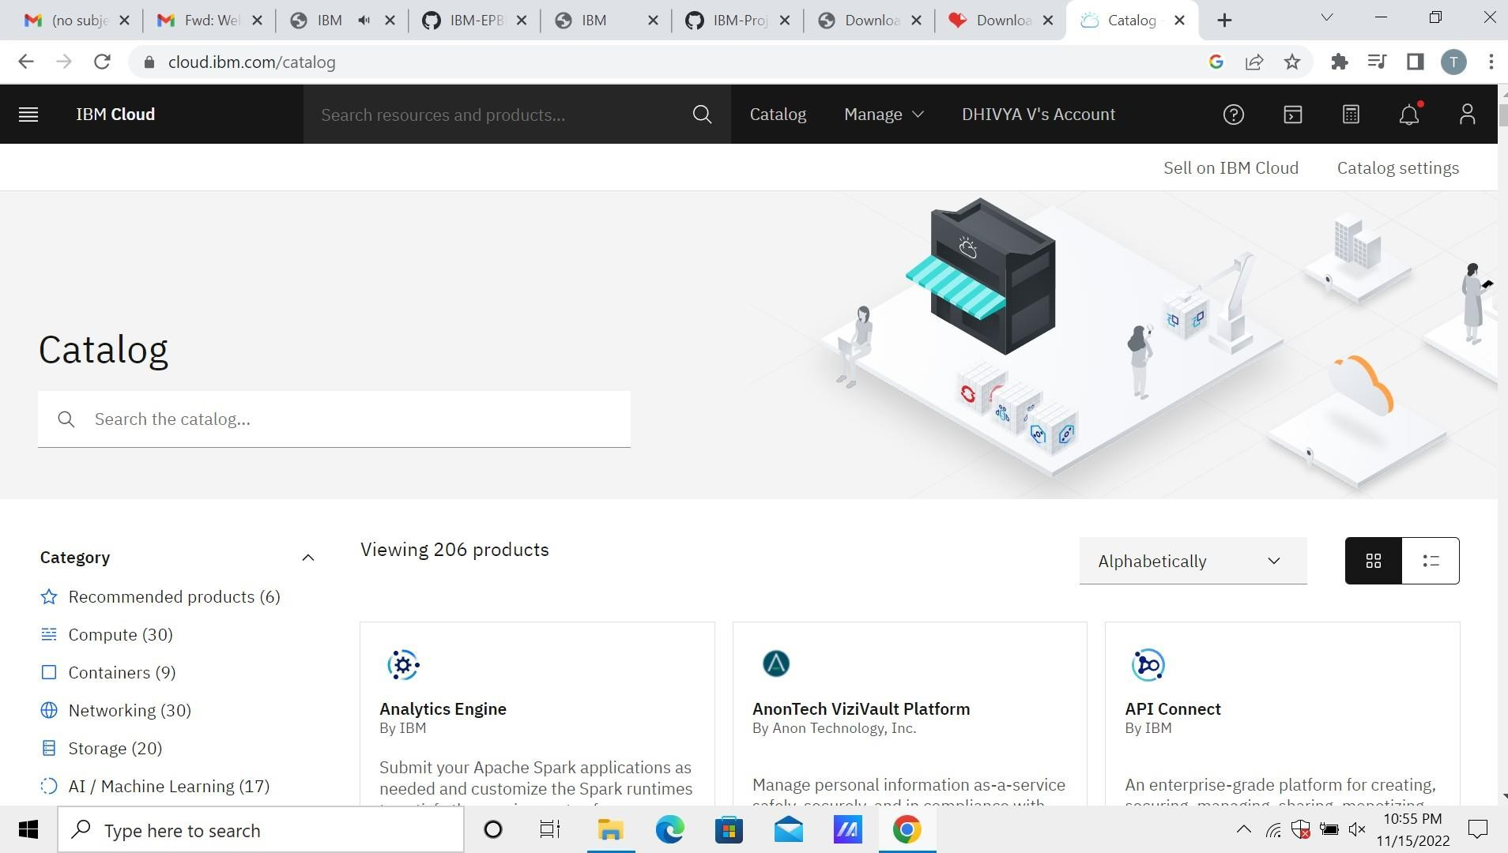Step1. Find the Node-RED Starter Kit in the IBM Cloud catalog

Step2. Create your application

Step3. Enable the Continuous Delivery feature Step4: Creation NODE RED

Step5:Simulated program to get the random values

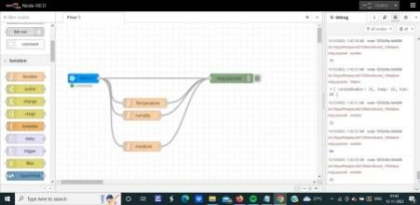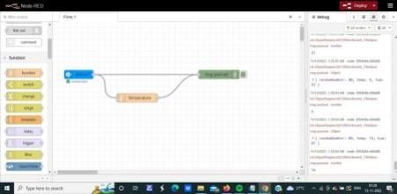

Step6:Generate debug message from IBM Watson IoT Platform and connect the nodes

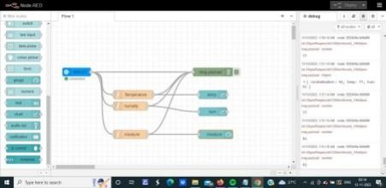

Step7:Generate the output from recent events

